**Running instructions:**

**Step1:**

Please import code in eclipse and run main method as below config as below

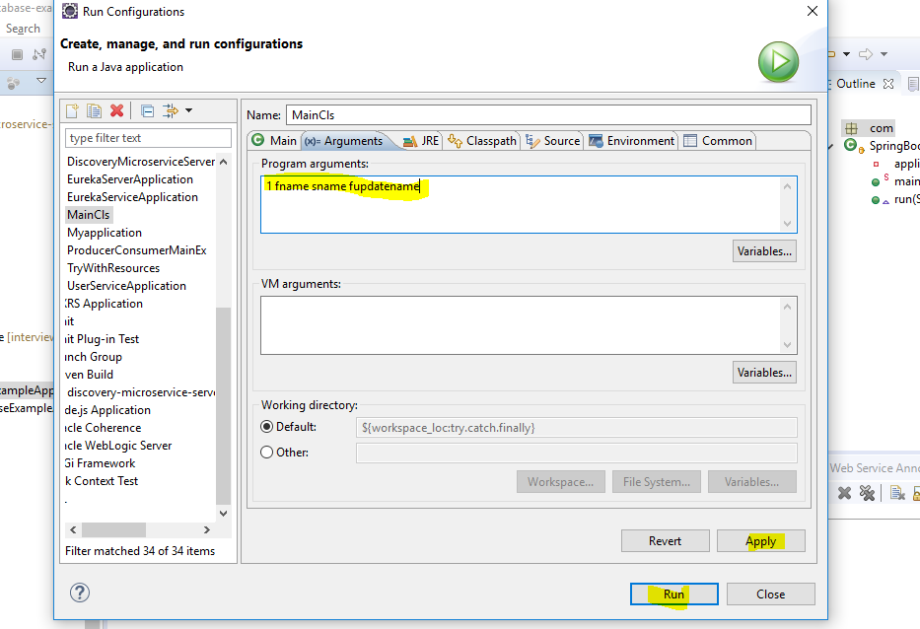

**Step2:**

Once successfully run springboot app then import postman collection and test application.